**Project Name:** Clothing Classification

**Github Link:** https://github.com/projectsforstudents2022/Clothing_Classification.git

**Why was this project created?**

The online fashion industry is constantly expanding, and an algorithm that can recognise clothing can assist businesses in the clothing sales industry in understanding the profile of potential customers and concentrating on sales targeting particular niches, as well as developing campaigns based on consumer preferences and enhancing user experience. Artificial intelligence methods that can recognise and categorize human clothing are required and can be applied to increase sales or comprehend consumers better. It has been demonstrated that convolutional neural network models are effective for picture classification.

**What problem is it solving?**

The goal of clothing categorization is to recognise and depict each feature in an image as a distinct garment that corresponds to the object or type of land cover that it actually represents on the ground. As online apparel buying grows, classification of garment images becomes increasingly crucial. The applications that are now used in clothing shopping, which are based on the technology of precise clothing picture classification, include clothing category labeling, clothing commodity retrieval, and similar clothing recommendations.

**Entire explanation of project**

* **PROPOSED APPROACH**

For the purpose of comparing machine learning methods, Fashion-MNIST is a direct drop-in replacement for the original MNIST dataset. The MNIST dataset, which consists of handwritten numbers, has 70000 greyscale 28x28 images linked to 10 labels, of which 60000 are from the training set and 10,000 from the testing set. CNN models were created in Python using Keras and TensorFlow to label this dataset. Using GPU, training was carried out in a Jupyter notebook. Weights and Biases was also utilized to gather data on training and hardware utilization. It features the same dropout and max pooling as previous models, however it only contains two convolutions, followed by a fully linked layer. Due to this model's single maximum pooling, the image has 14x14 pixels when it reaches the dense layer. Applied thick convolutional layers Except for the final dense layer of each model (the output layer), ReLU activation algorithms employed Softmax. We trained the models for 10 epochs with Adam as the optimizer, and the batch size was 128. Results were enhanced by normalizing image pixel brightness values to float numbers between 0 and 1. The model with the highest accuracy on the training dataset was cnn, with 91.29% accuracy.

* **WORKFLOW DIAGRAM**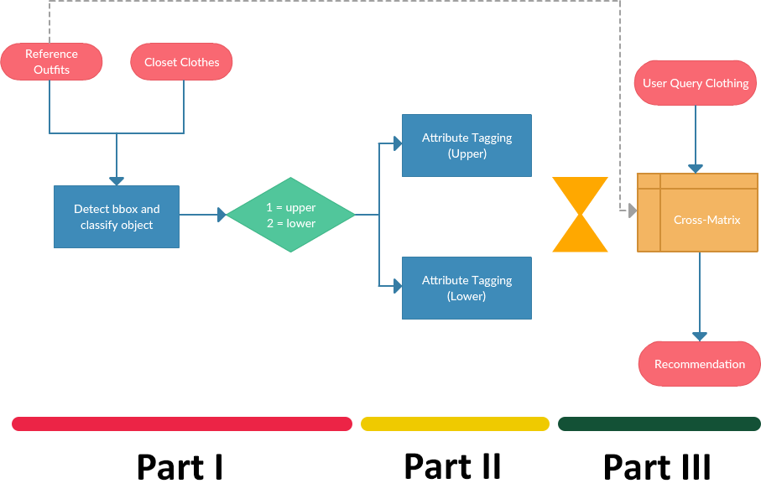
* **RESULT**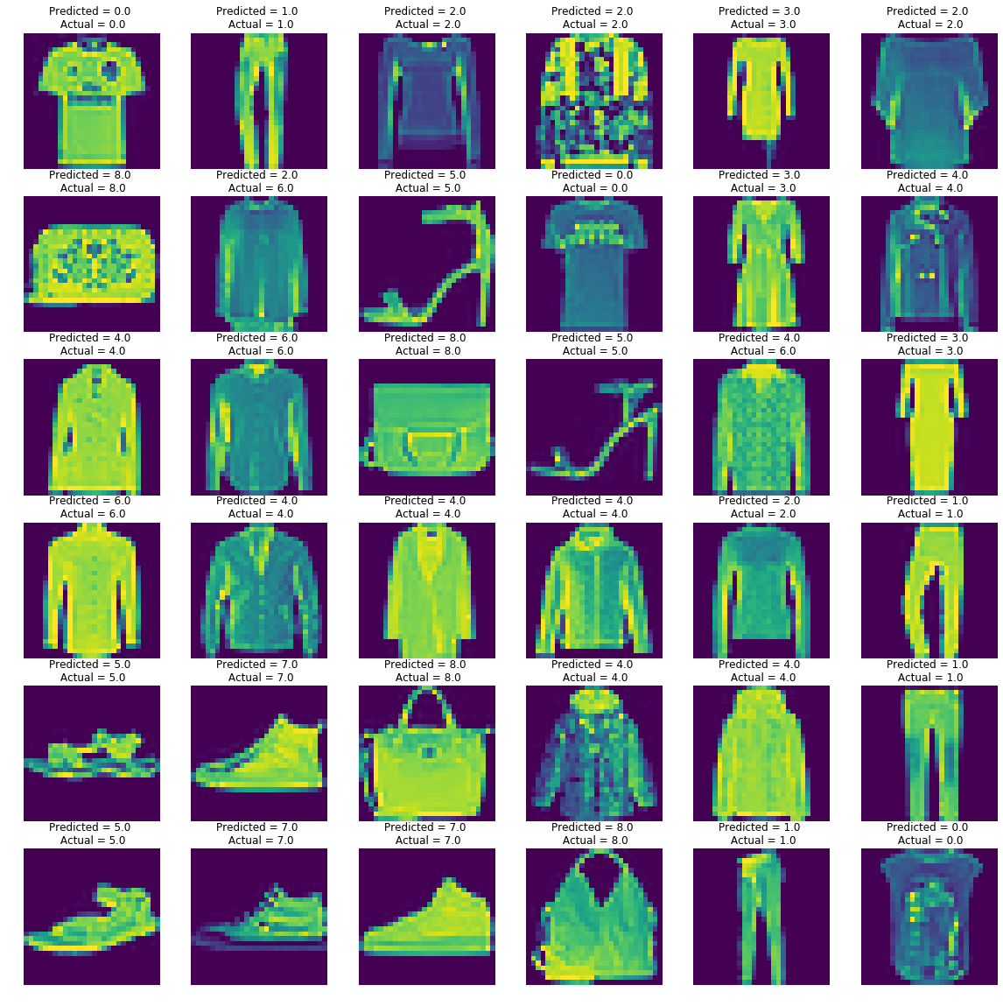
* **CONCLUSION**

The obtained results provide evidence that CNN can categorise fashion products more accurately than other traditional machine learning models. Additionally, it was found that the dropout strategy works well for lowering a model's bias when combined with more convolutive layers.